In the early 1830s, this image regularly accompanied the “Ladies Department” section of the abolitionist newspaper The Liberator.

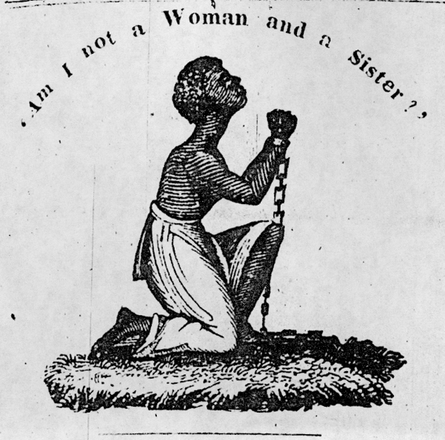
http://www.dhr.history.vt.edu/modules/us/mod04_women/images/9.jpg

This variation on the image appeared on the title page of Lydia Maria Child’s 1838 book Authentic Anecdotes of American Slavery.
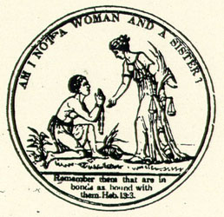
http://memory.loc.gov:8081/cgi-bin/ampage?collId=rbaapc&fileName=05000/rbaapc05000.db&recNum=0

